

Smart Parking Space

Embedded Systems

Done by: Zaid Hamzeh Ahmad Khawaja

Mohammad Anis

Supervisor: Prof. Anastassia Gharib

Prof. Belal Sababhah

***Abstract***

*The Smart Parking Space project introduces innovation with smart sensors and a smart gate system. Through real-time sensor data, the system predicts parking availability, enhancing user experience and reducing search times. Emphasizing sustainability, smart sensors optimize resource use, minimizing traffic congestion. User-friendly features contribute to a comprehensive solution, fostering improved urban mobility and environmental conservation.*

Contents

**1.****Introduction** 2

**2.****Components Used** 2

**3.****Project Procedure** 5

# **Introduction**

Our Smart Parking Space project brings a new level of smartness to parking lots, making it easy and efficient. We've got cool tech like infrared (IR) sensors, ultrasonic sensors, LEDs, LCDs, and servo motors. When a car comes close, the ultrasonic sensor notices and opens the gate with a smooth motor. Inside, IR sensors know if there's a car, and green and red lights show if the spot is free or taken. It's not just about making things easy for you – it's also about using tech to be smarter with parking and helping our cities be more sustainable.

# **Components Used**

We used a variety of different components; all are working together to make the system run smoothly. Here are all the components used in this project.

1. **TCRT5000 IR Sensor:**

* **Type:** Reflective Optical Sensor
* **Function:** Detects the presence of a vehicle within the parking space by measuring the reflected infrared light.
* **Usage:** Provides accurate information about parking space occupancy.
* 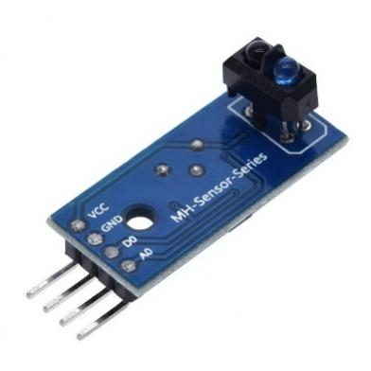**Benefit:** Offers a cost-effective and reliable solution for vehicle detection, optimizing parking management.

1. **Ultrasonic Sensor:**

* **Type:** Single-beam Ultrasonic Sensor
* **Function:** Measures the distance between the sensor and the vehicle to facilitate gate control.
* **Usage:** Initiates gate opening when a vehicle is detected approaching.
* 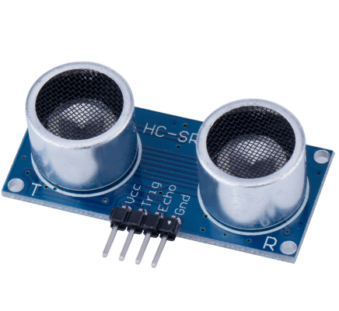**Benefit:** Ensures smooth and timely entry of vehicles into the parking space.

1. **LEDs (Light-Emitting Diodes):**

**Type:** Green and Red LEDs

**Function:** Visual indication of parking space availability.

**Usage:** Green LED for available spaces, red LED for occupied spaces.

**Benefit:** Provides clear and immediate information to users, reducing search time.

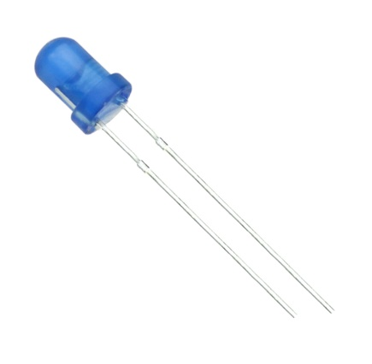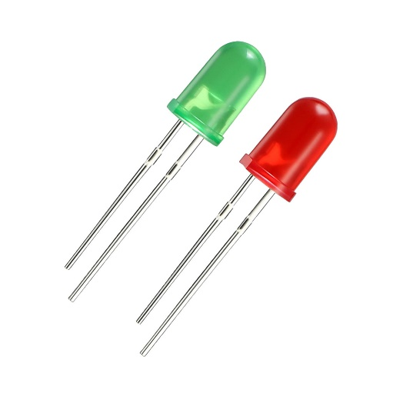

1. **LCD (Liquid Crystal Display):**

* **Type:** Monochrome LCD Display
* **Function:** Displays relevant information such as system status and instructions.
* **Usage:** Communicates messages to users and enhances user interaction.
* **Benefit:** Improves user experience and provides informative feedback.

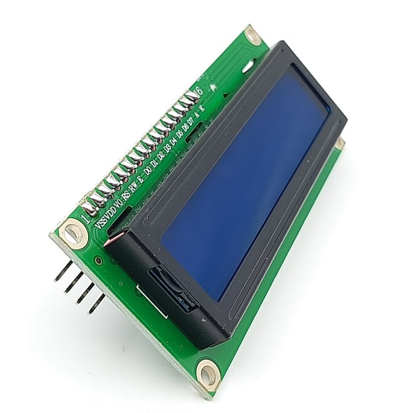

1. **Servo Motor:**

* **Type:** Micro Servo Motor
* **Function:** Controls the opening and closing of the parking gate.
* **Usage:** Activated by the ultrasonic sensor when a vehicle is detected for smooth gate operation.
* **Benefit:** Ensures reliable and precise gate control, enhancing overall system efficiency.

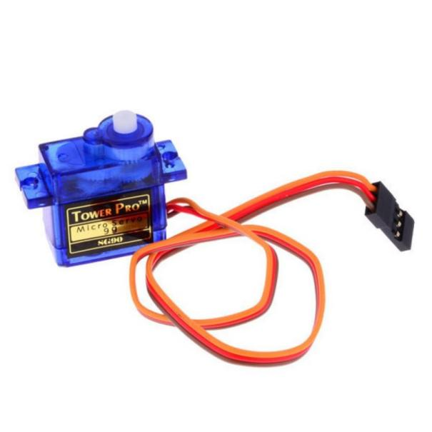

1. **Microcontroller (PIC16F877a):**

* Type: 8-bit Microcontroller
* Function: Controls and coordinates the operation of various components within the Smart Parking Space system.
* Usage: Manages data processing, decision-making, and communication between sensors, actuators, and the user interface.
* Benefit: Enables efficient and reliable control of the parking system, contributing to overall system intelligence.

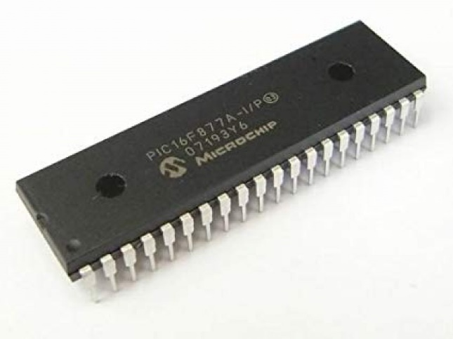

# **Project Procedure**

The Smart Parking Space project follows a step-by-step process to work well. First, we start the system and open the gate when a car is near using sensors. The project uses lights to show if a parking space is free (green) or taken (red). There's also a screen that gives information to users. We keep an eye on the parking spaces, and if one is taken, we close the gate. Before putting it in place, we test and make sure everything works smoothly. This way, the project makes parking easy and helps cities manage parking better.

